Assignment 2

Simen Ljøstad

2026-10-10
#Purpose: #Examining how wolf pup numbers are associated with moose abundance, wolf parasite load, and hunting permits.
#Data description: #The ecological setting provides context for practising multiple regression; the data are not evidence about a real ecosystem. The predictor variables included in the dataset are the number of adult moose in the park (ADULTS), the number of moose calves born (CALVES), the average blood helminth load (WORMS) of trapped wolves (determined using blood samples from randomly selected wolves every year), and the number of moose hunting permits (PERMITS) issued by the park to human hunters. #Source: Made up data for a practical excerise
#Libraries ####
library(car)
library(GGally)
library(performance)
library(tidyverse)
#Load dataset
df_WOLFPUPS<-read_csv("WOLFPUPS.csv")
## Rows: 45 Columns: 6
## ── Column specification ─────────────────────────────────────────────────────────────────
## Delimiter: ","
## dbl (6): YEAR, ADULTS, CALVES, WORMS, PERMITS, PUPS
##
## ℹ Use `spec()` to retrieve the full column specification for this data.
## ℹ Specify the column types or set `show_col_types = FALSE` to quiet this message.
#Data quality control ####
str(df_WOLFPUPS)
## spc_tbl_ [45 × 6] (S3: spec_tbl_df/tbl_df/tbl/data.frame)
## $ YEAR : num [1:45] 1955 1956 1957 1958 1959 ...
## $ ADULTS : num [1:45] 559 287 459 599 765 340 377 506 530 517 ...
## $ CALVES : num [1:45] 122 67 98 120 158 72 105 106 109 109 ...
## $ WORMS : num [1:45] 0.518 0.95 0.537 1.032 0.991 ...
## $ PERMITS: num [1:45] 24 21 33 35 28 25 18 18 17 22 ...
## $ PUPS : num [1:45] 13 6 13 6 10 5 13 7 5 12 ...
## - attr(*, "spec")=
## .. cols(
## .. YEAR = col_double(),
## .. ADULTS = col_double(),
## .. CALVES = col_double(),
## .. WORMS = col_double(),
## .. PERMITS = col_double(),
## .. PUPS = col_double()
## .. )
## - attr(*, "problems")=<pointer: 0x0000027071e8d500>
plot(df_WOLFPUPS)
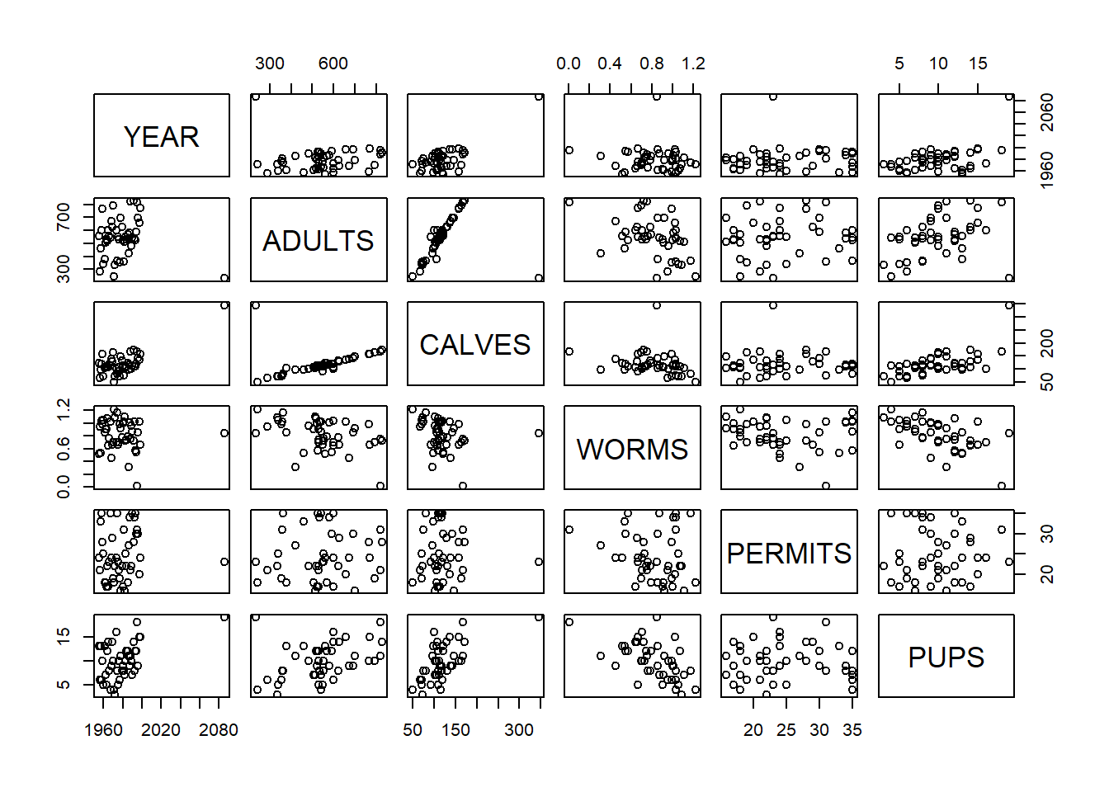
#Histograms for each predictor
hist(df_WOLFPUPS$YEAR) #Datapoint from 2086??
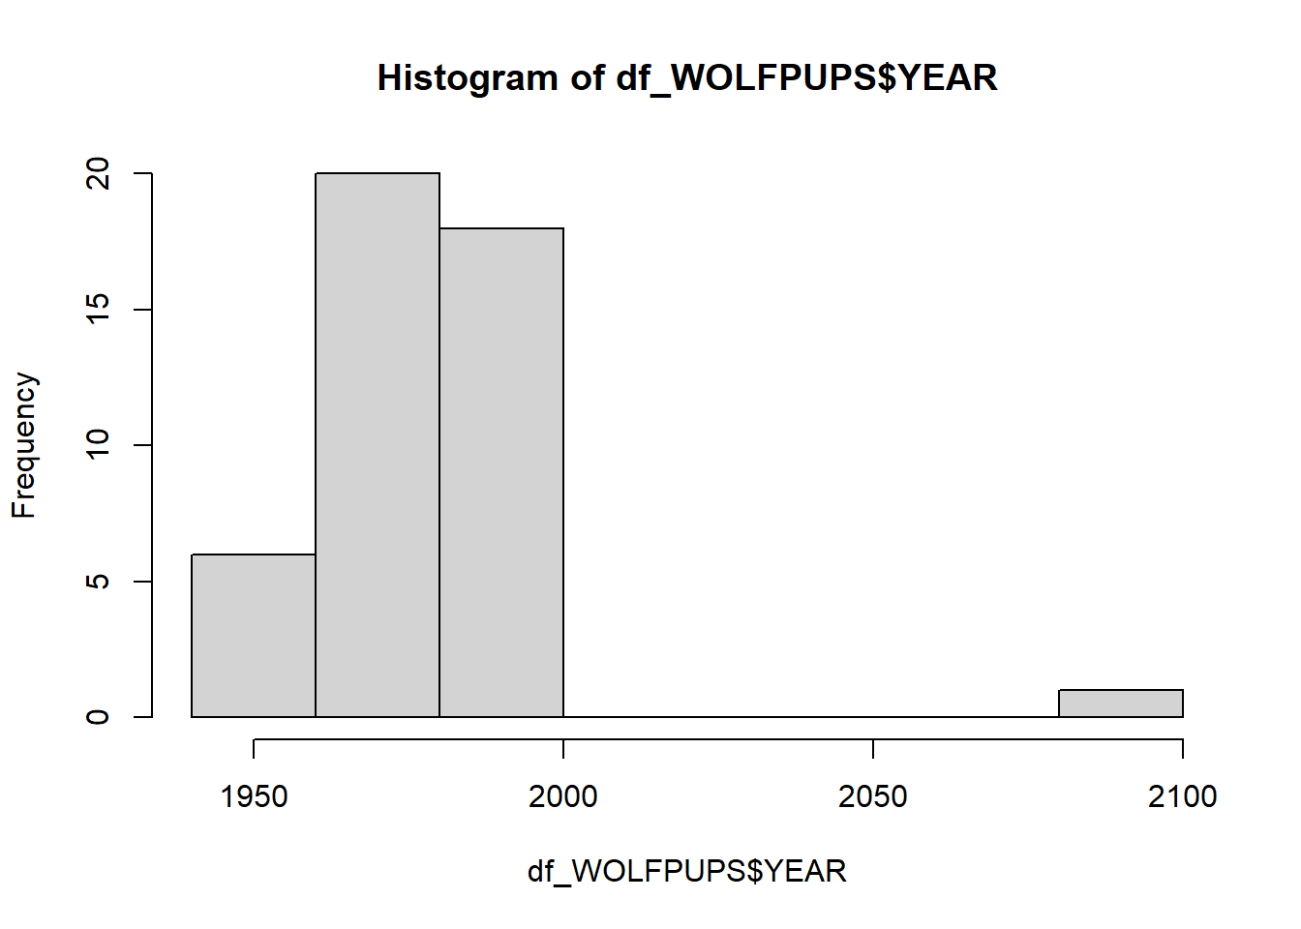
hist(df_WOLFPUPS$ADULTS)
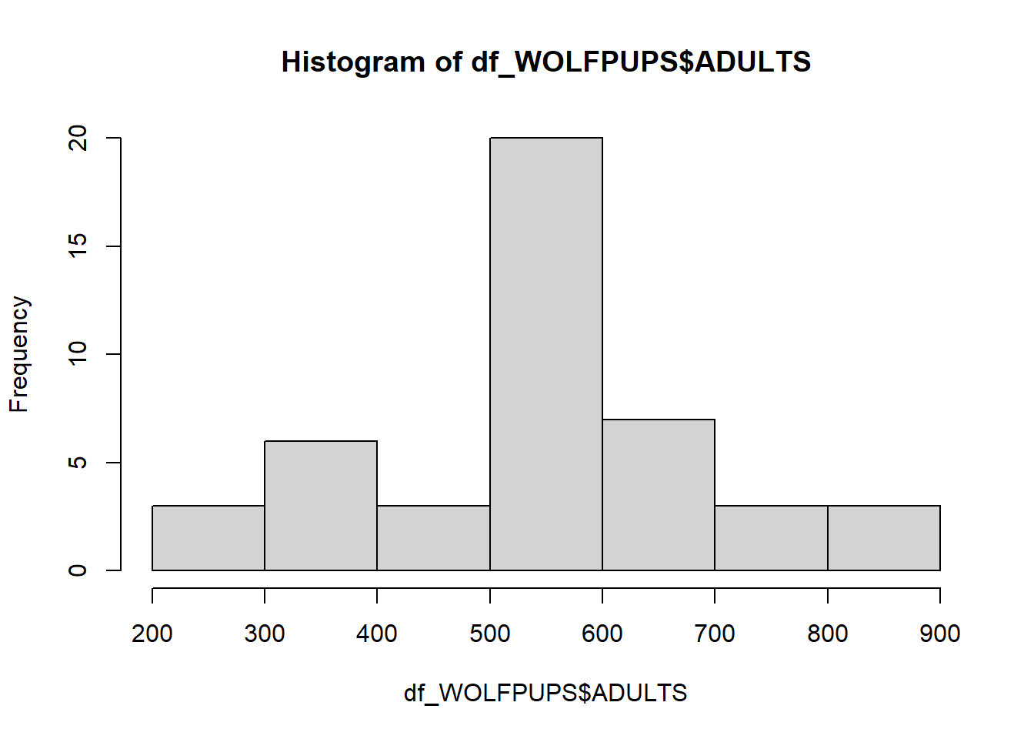
hist(df_WOLFPUPS$CALVES)
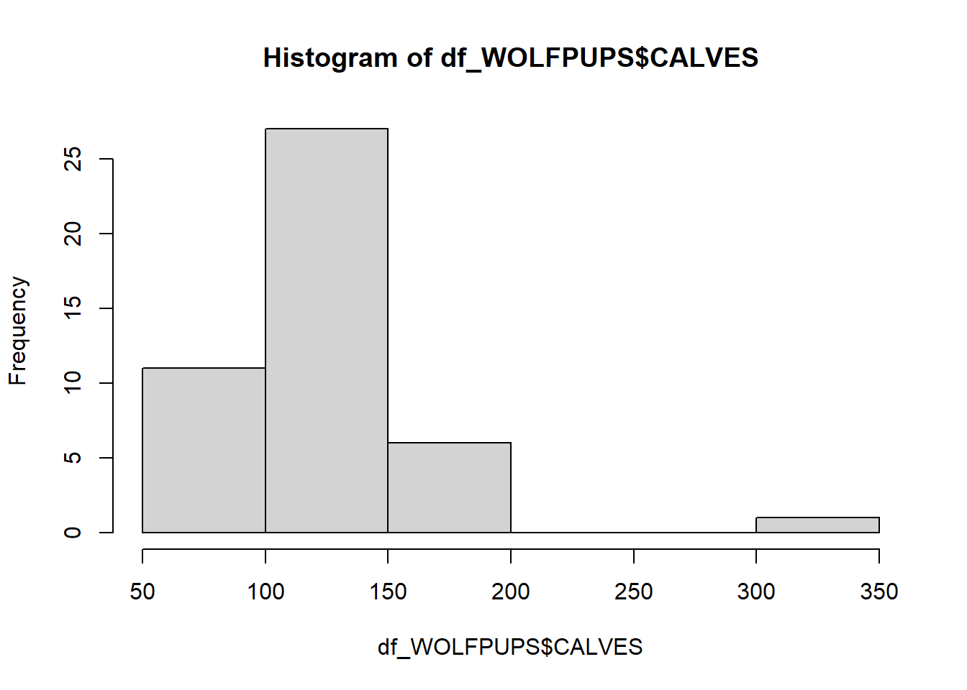
hist(df_WOLFPUPS$WORMS)
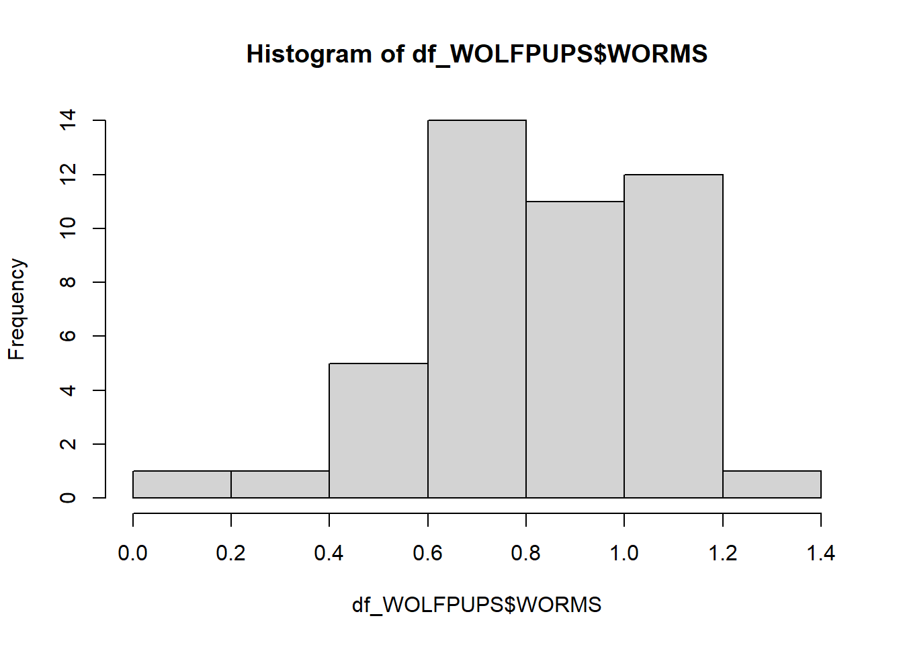
hist(df_WOLFPUPS$PERMITS)
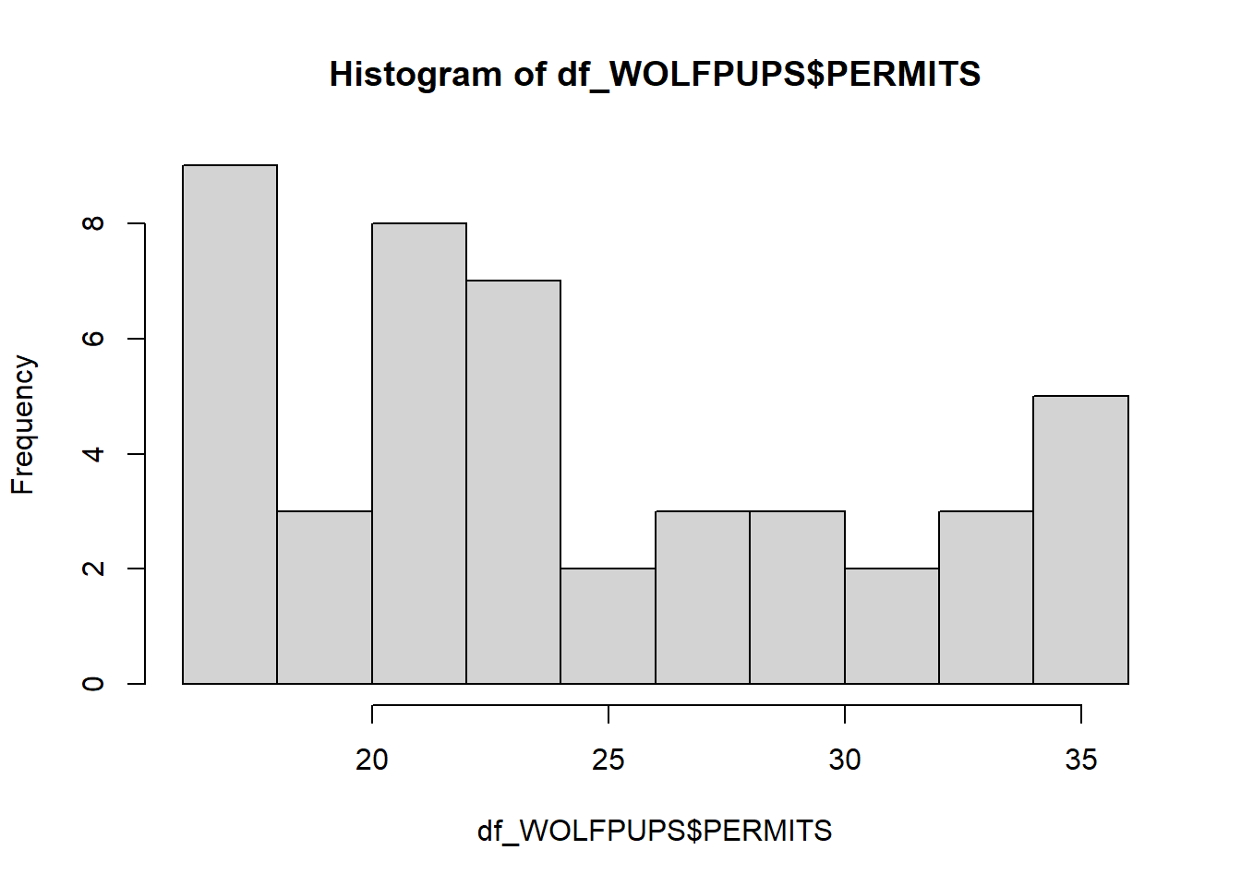
hist(df_WOLFPUPS$PUPS)
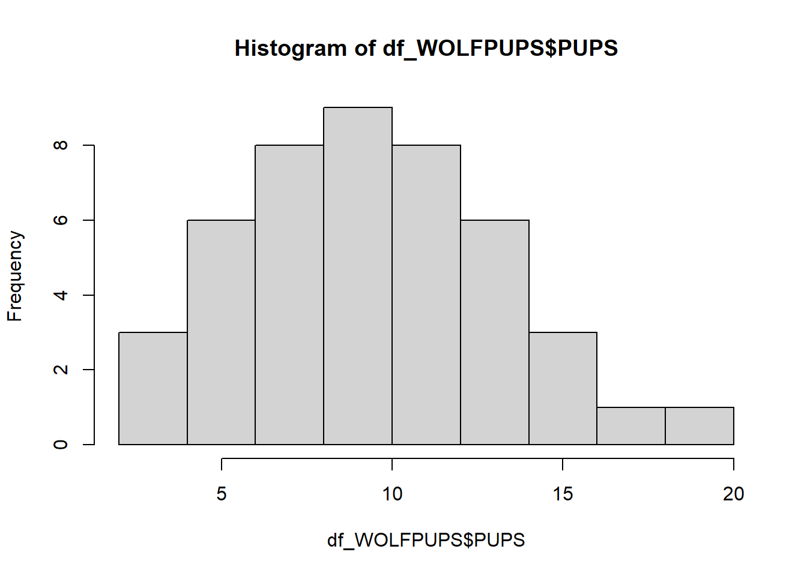
df_WOLFPUPS.corr <- df_WOLFPUPS%>%
filter(YEAR<2026)
#Checking corrected data
plot(df_WOLFPUPS.corr)
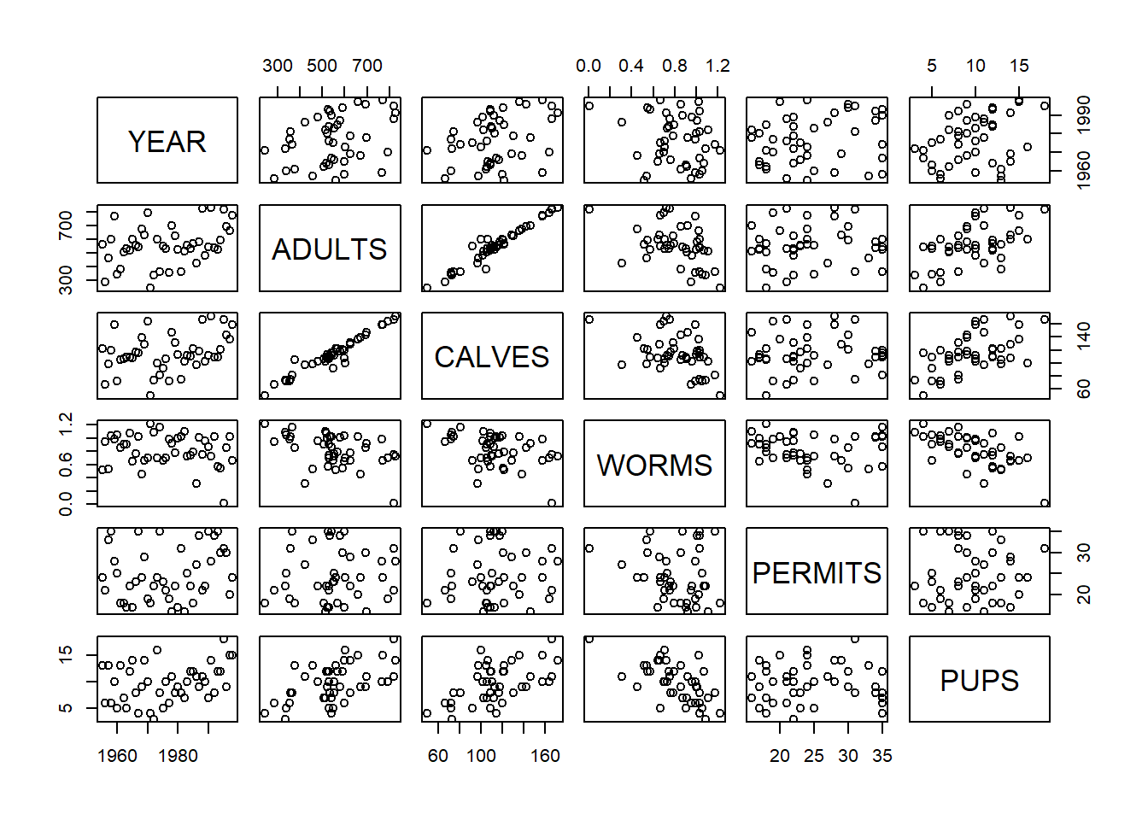
hist(df_WOLFPUPS.corr$YEAR)
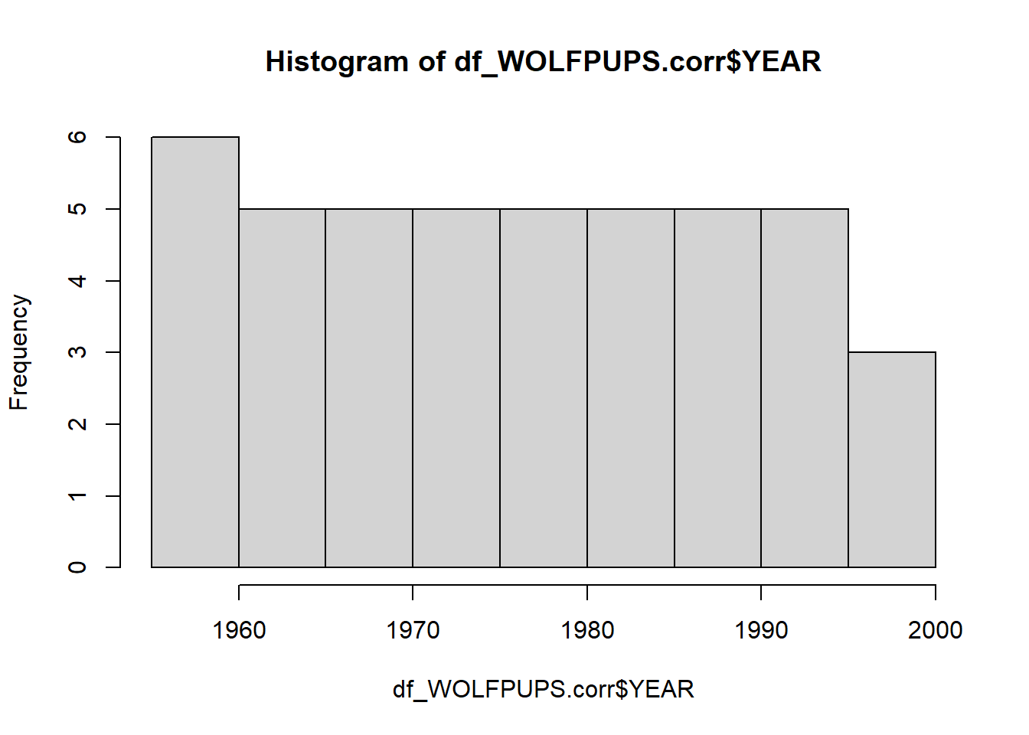
hist(df_WOLFPUPS.corr$ADULTS)
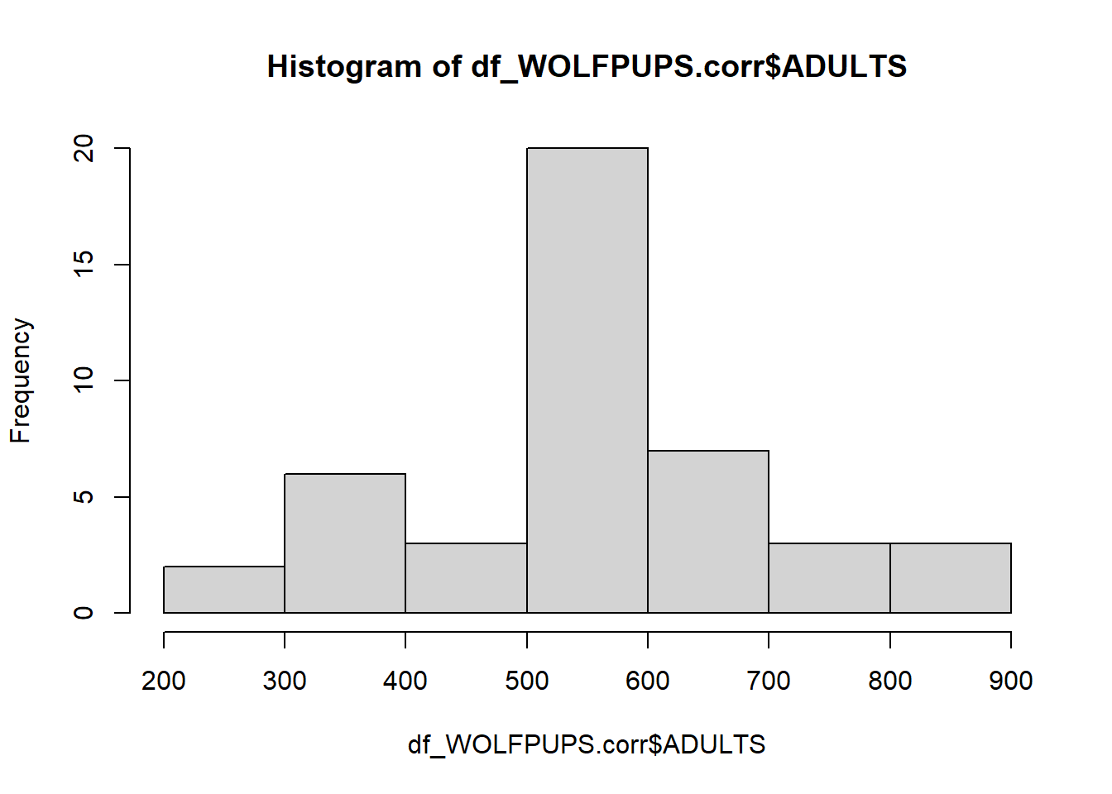
hist(df_WOLFPUPS.corr$CALVES)
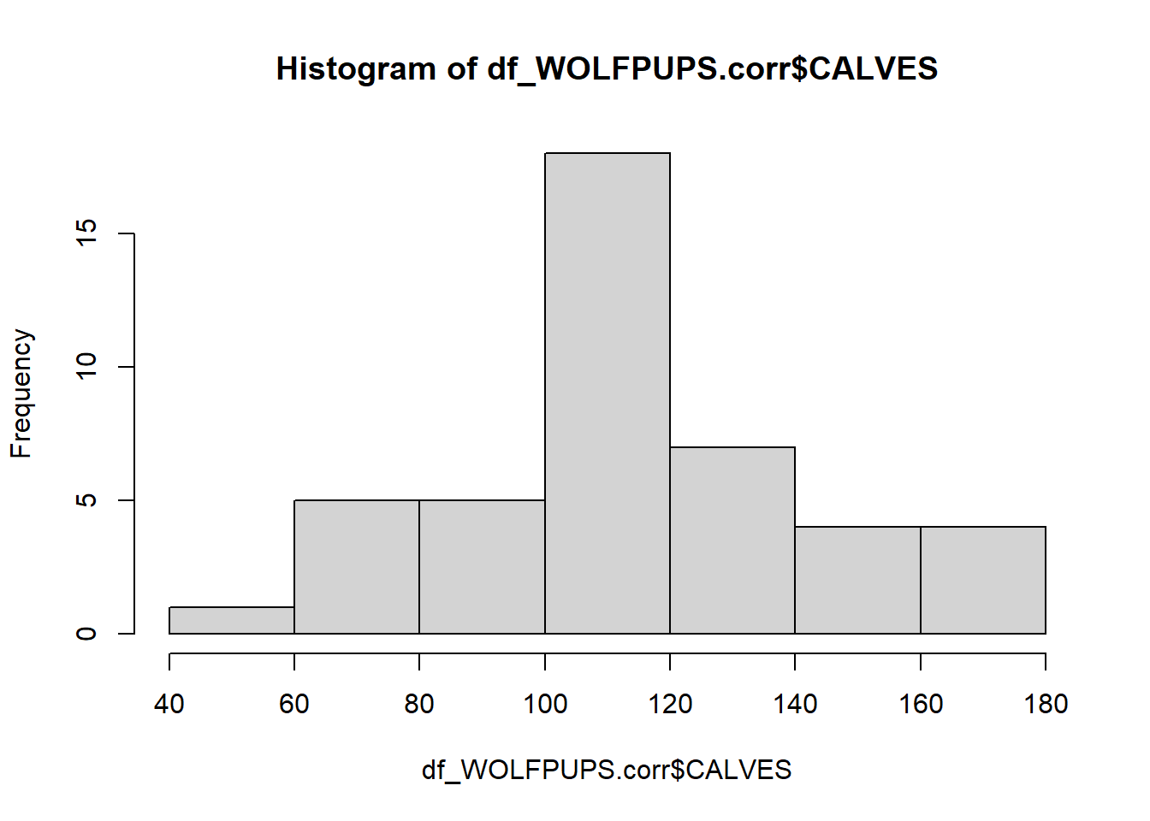
hist(df_WOLFPUPS.corr$WORMS)
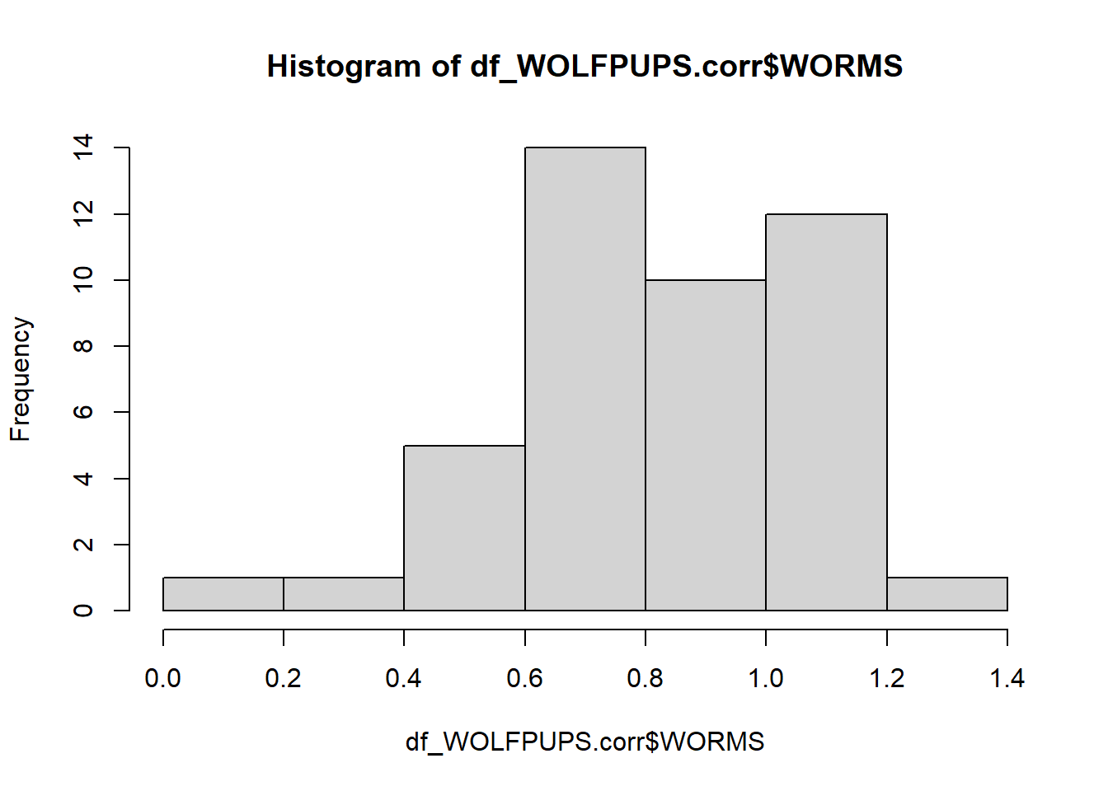
hist(df_WOLFPUPS.corr$PERMITS)
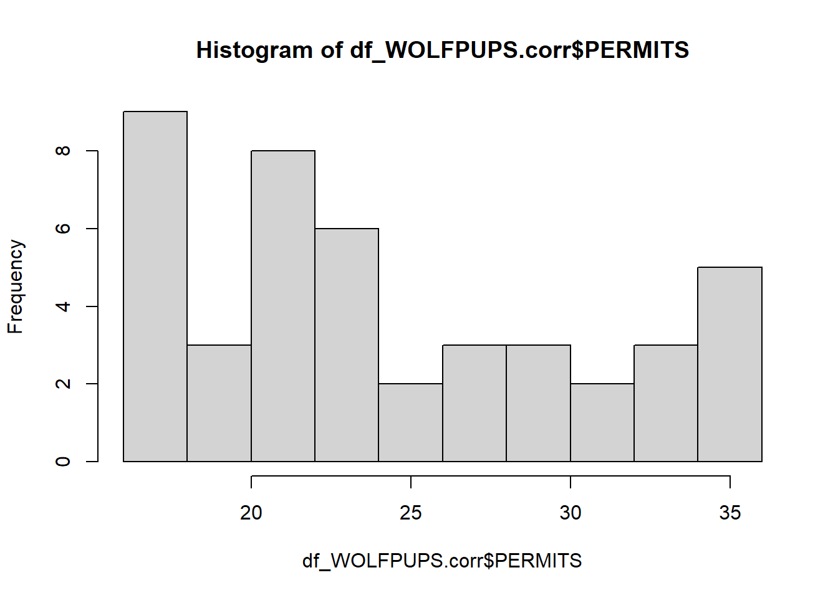
hist(df_WOLFPUPS.corr$PUPS)
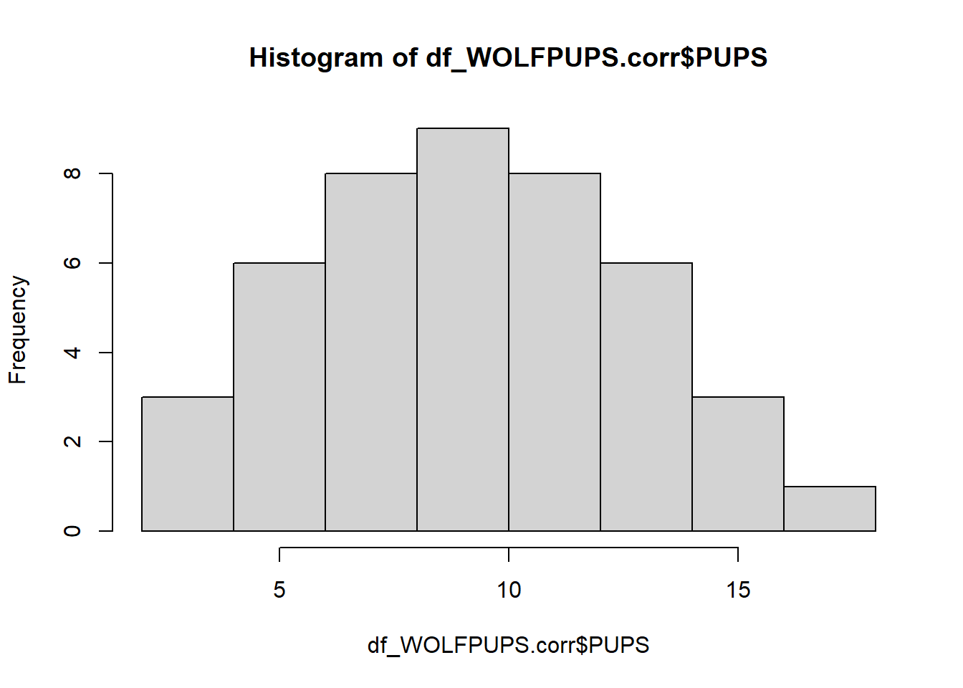
#Checking for colinearity
ggpairs(df_WOLFPUPS.corr)
## plot: [1, 1] [=>--------------------------------------------------------] 3% est: 0s
## plot: [1, 2] [==>-------------------------------------------------------] 6% est: 1s
## plot: [1, 3] [====>-----------------------------------------------------] 8% est: 2s
## plot: [1, 4] [=====>----------------------------------------------------] 11% est: 2s
## plot: [1, 5] [=======>--------------------------------------------------] 14% est: 2s
## plot: [1, 6] [=========>------------------------------------------------] 17% est: 2s
## plot: [2, 1] [==========>-----------------------------------------------] 19% est: 2s
## plot: [2, 2] [============>---------------------------------------------] 22% est: 2s
## plot: [2, 3] [=============>--------------------------------------------] 25% est: 2s
## plot: [2, 4] [===============>------------------------------------------] 28% est: 2s
## plot: [2, 5] [=================>----------------------------------------] 31% est: 2s
## plot: [2, 6] [==================>---------------------------------------] 33% est: 2s
## plot: [3, 1] [====================>-------------------------------------] 36% est: 2s
## plot: [3, 2] [======================>-----------------------------------] 39% est: 2s
## plot: [3, 3] [=======================>----------------------------------] 42% est: 2s
## plot: [3, 4] [=========================>--------------------------------] 44% est: 1s
## plot: [3, 5] [==========================>-------------------------------] 47% est: 1s
## plot: [3, 6] [============================>-----------------------------] 50% est: 1s
## plot: [4, 1] [==============================>---------------------------] 53% est: 1s
## plot: [4, 2] [===============================>--------------------------] 56% est: 1s
## plot: [4, 3] [=================================>------------------------] 58% est: 1s
## plot: [4, 4] [==================================>-----------------------] 61% est: 1s
## plot: [4, 5] [====================================>---------------------] 64% est: 1s
## plot: [4, 6] [======================================>-------------------] 67% est: 1s
## plot: [5, 1] [=======================================>------------------] 69% est: 1s
## plot: [5, 2] [=========================================>----------------] 72% est: 1s
## plot: [5, 3] [===========================================>--------------] 75% est: 1s
## plot: [5, 4] [============================================>-------------] 78% est: 1s
## plot: [5, 5] [==============================================>-----------] 81% est: 0s
## plot: [5, 6] [===============================================>----------] 83% est: 0s
## plot: [6, 1] [=================================================>--------] 86% est: 0s
## plot: [6, 2] [===================================================>------] 89% est: 0s
## plot: [6, 3] [====================================================>-----] 92% est: 0s
## plot: [6, 4] [======================================================>---] 94% est: 0s
## plot: [6, 5] [=======================================================>--] 97% est: 0s
## plot: [6, 6] [==========================================================]100% est: 0s
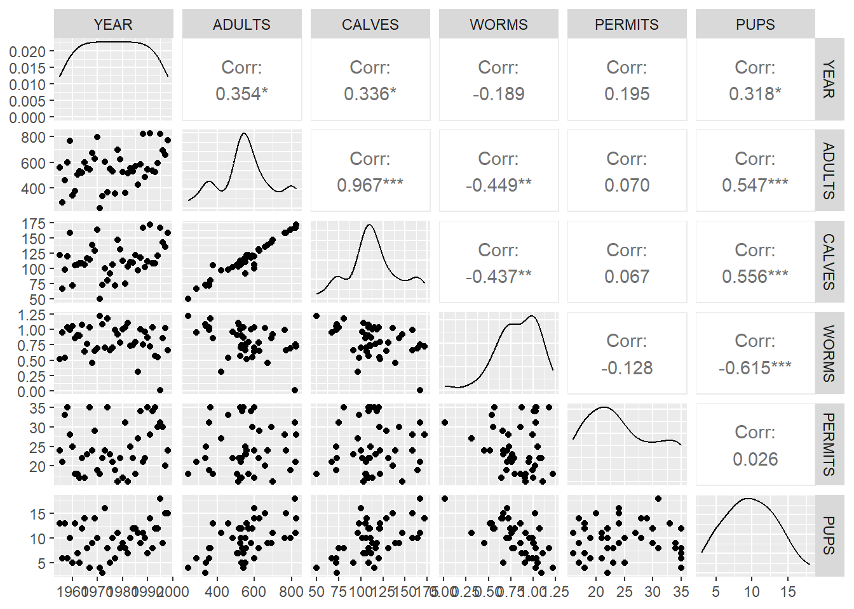
#Constructing a model and model diagnostics ####
MOD.1<-lm(PUPS~ADULTS+
CALVES+
WORMS+
PERMITS,
data=df_WOLFPUPS.corr)

check_model(MOD.1) #Adults and calves have high colinearity
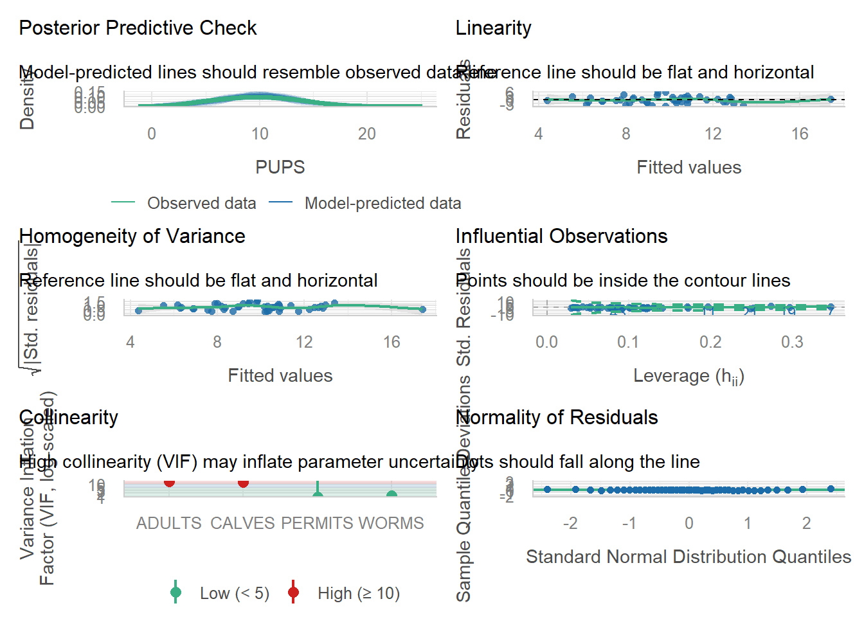
MOD.2 <- update(MOD.1,~.- ADULTS)
check_model(MOD.2) #Colinearity is acceptable now
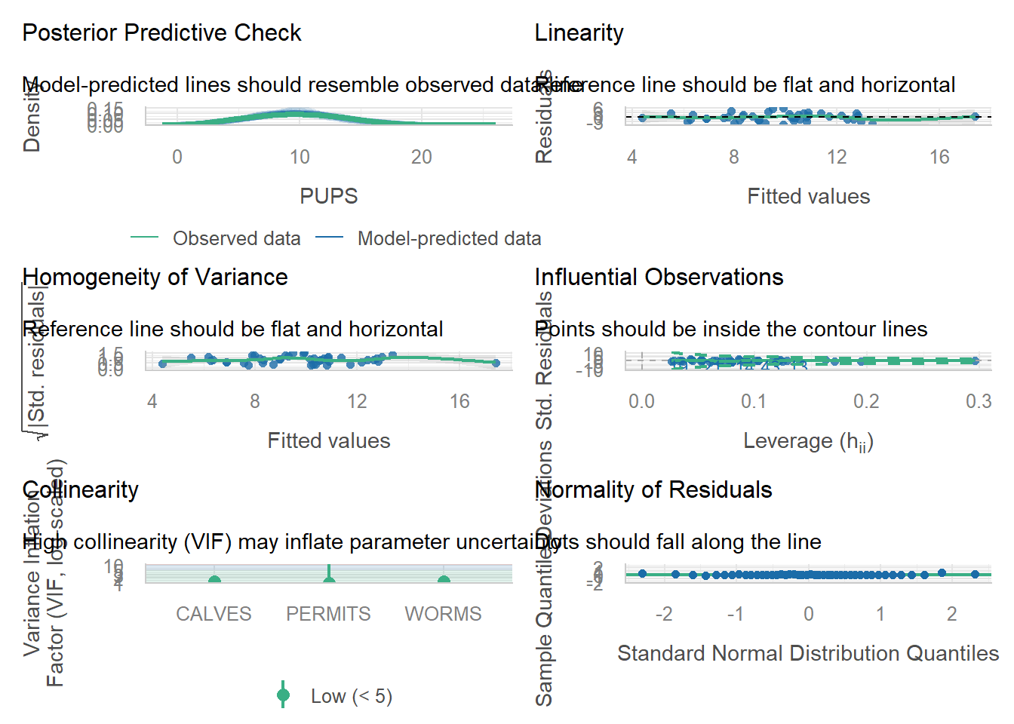
#Test if there is a difference in removing calves instead?
MOD.3 <- update(MOD.1,~.- CALVES)
check_model(MOD.3) #Not much of a difference
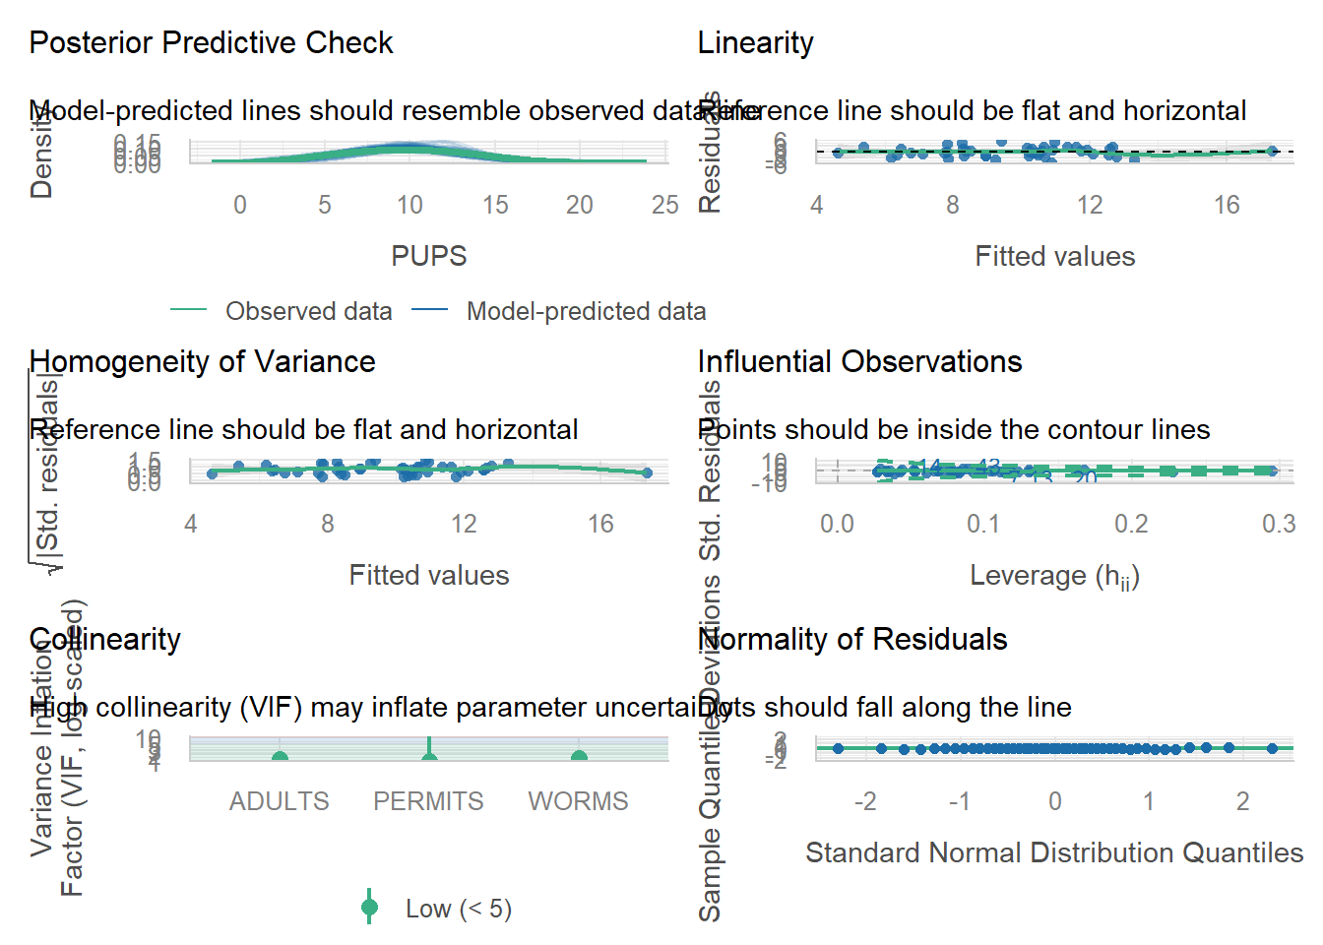
#Model simplification ####
summary(MOD.2) #Permits have the lowest effect
##
## Call:
## lm(formula = PUPS ~ CALVES + WORMS + PERMITS, data = df_WOLFPUPS.corr)
##
## Residuals:
## Min 1Q Median 3Q Max
## -4.896 -1.713 -0.001 1.650 6.088
##
## Coefficients:
## Estimate Std. Error t value Pr(>|t|)
## (Intercept) 11.16643 3.34793 3.335 0.00185 **
## CALVES 0.04406 0.01566 2.813 0.00757 **
## WORMS -6.87087 1.86778 -3.679 0.00069 ***
## PERMITS -0.03349 0.06587 -0.508 0.61400
## ---
## Signif. codes: 0 '***' 0.001 '**' 0.01 '*' 0.05 '.' 0.1 ' ' 1
##
## Residual standard error: 2.641 on 40 degrees of freedom
## Multiple R-squared: 0.4835, Adjusted R-squared: 0.4448
## F-statistic: 12.48 on 3 and 40 DF, p-value: 6.69e-06
MOD.4 <- update(MOD.2,~.- PERMITS)
anova(MOD.2, MOD.4) #Test if new model is significantly worse
## Analysis of Variance Table
##
## Model 1: PUPS ~ CALVES + WORMS + PERMITS
## Model 2: PUPS ~ CALVES + WORMS
## Res.Df RSS Df Sum of Sq F Pr(>F)
## 1 40 279.05
## 2 41 280.85 -1 -1.8028 0.2584 0.614
summary(MOD.4)
##
## Call:
## lm(formula = PUPS ~ CALVES + WORMS, data = df_WOLFPUPS.corr)
##
## Residuals:
## Min 1Q Median 3Q Max
## -4.8239 -1.7410 -0.1149 1.7320 6.1227
##
## Coefficients:
## Estimate Std. Error t value Pr(>|t|)
## (Intercept) 10.26475 2.81364 3.648 0.000739 ***
## CALVES 0.04396 0.01552 2.833 0.007127 **
## WORMS -6.76661 1.83962 -3.678 0.000676 ***
## ---
## Signif. codes: 0 '***' 0.001 '**' 0.01 '*' 0.05 '.' 0.1 ' ' 1
##
## Residual standard error: 2.617 on 41 degrees of freedom
## Multiple R-squared: 0.4802, Adjusted R-squared: 0.4548
## F-statistic: 18.93 on 2 and 41 DF, p-value: 1.498e-06
#Test to try to remove the next one
MOD.5 <- update(MOD.4,~.- CALVES)
anova(MOD.4, MOD.5) #High F-value, so Calves should not be removed
## Analysis of Variance Table
##
## Model 1: PUPS ~ CALVES + WORMS
## Model 2: PUPS ~ WORMS
## Res.Df RSS Df Sum of Sq F Pr(>F)
## 1 41 280.85
## 2 42 335.81 -1 -54.964 8.024 0.007127 **
## ---
## Signif. codes: 0 '***' 0.001 '**' 0.01 '*' 0.05 '.' 0.1 ' ' 1
#Centering and scaling ####
summary(MOD.4)
##
## Call:
## lm(formula = PUPS ~ CALVES + WORMS, data = df_WOLFPUPS.corr)
##
## Residuals:
## Min 1Q Median 3Q Max
## -4.8239 -1.7410 -0.1149 1.7320 6.1227
##
## Coefficients:
## Estimate Std. Error t value Pr(>|t|)
## (Intercept) 10.26475 2.81364 3.648 0.000739 ***
## CALVES 0.04396 0.01552 2.833 0.007127 **
## WORMS -6.76661 1.83962 -3.678 0.000676 ***
## ---
## Signif. codes: 0 '***' 0.001 '**' 0.01 '*' 0.05 '.' 0.1 ' ' 1
##
## Residual standard error: 2.617 on 41 degrees of freedom
## Multiple R-squared: 0.4802, Adjusted R-squared: 0.4548
## F-statistic: 18.93 on 2 and 41 DF, p-value: 1.498e-06
MOD.4s <- lm(PUPS ~ scale(CALVES) + scale(WORMS),
data = df_WOLFPUPS.corr)
summary(MOD.4s) #Worms is the higher predictor
##
## Call:
## lm(formula = PUPS ~ scale(CALVES) + scale(WORMS), data = df_WOLFPUPS.corr)
##
## Residuals:
## Min 1Q Median 3Q Max
## -4.8239 -1.7410 -0.1149 1.7320 6.1227
##
## Coefficients:
## Estimate Std. Error t value Pr(>|t|)
## (Intercept) 9.7500 0.3946 24.711 < 2e-16 ***
## scale(CALVES) 1.2567 0.4436 2.833 0.007127 **
## scale(WORMS) -1.6318 0.4436 -3.678 0.000676 ***
## ---
## Signif. codes: 0 '***' 0.001 '**' 0.01 '*' 0.05 '.' 0.1 ' ' 1
##
## Residual standard error: 2.617 on 41 degrees of freedom
## Multiple R-squared: 0.4802, Adjusted R-squared: 0.4548
## F-statistic: 18.93 on 2 and 41 DF, p-value: 1.498e-06
#Inspecting added variable plots
avPlots(MOD.4)
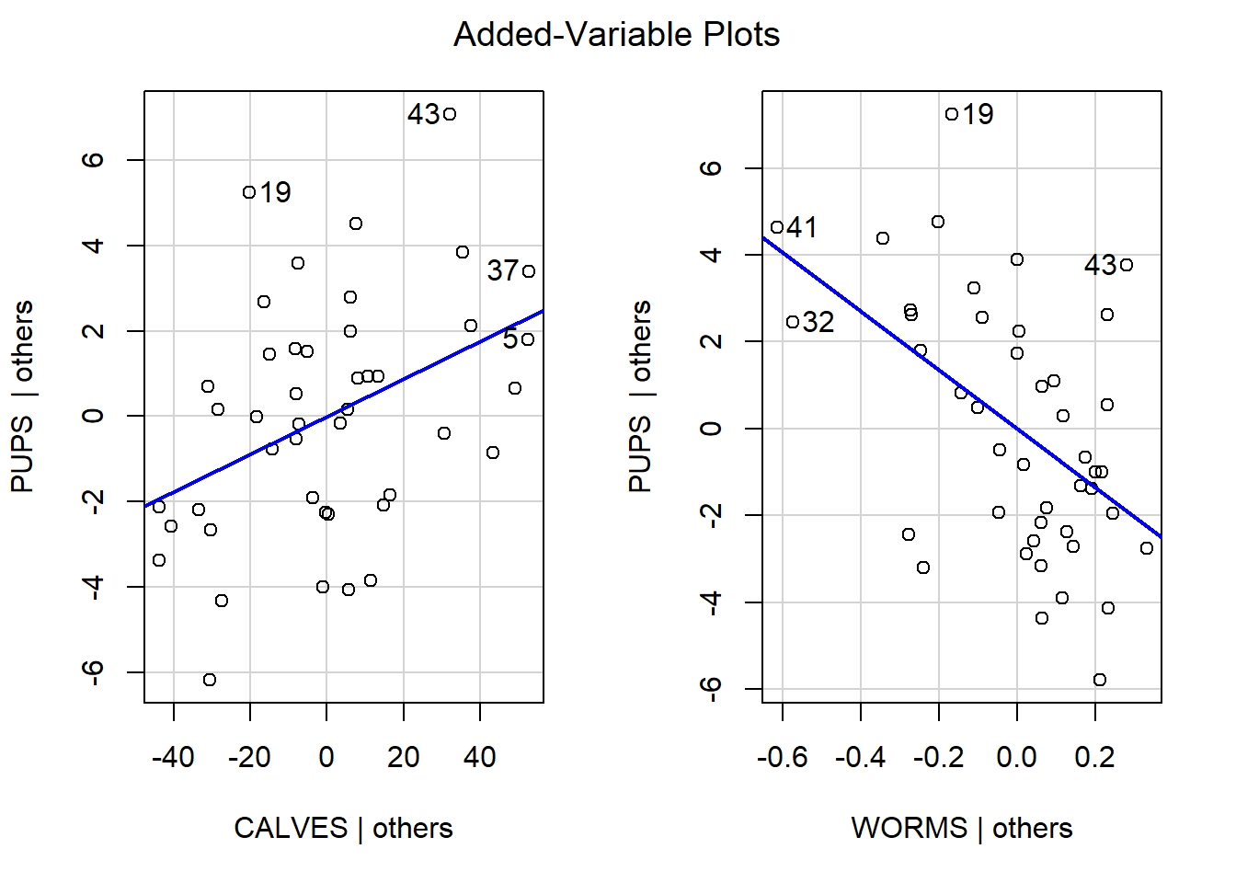
#Visualizing Partial Effects ####
summary(df_WOLFPUPS.corr)
## YEAR ADULTS CALVES WORMS PERMITS
## Min. :1955 Min. :243.0 Min. : 50.0 Min. :0.01152 Min. :16.00
## 1st Qu.:1966 1st Qu.:500.0 1st Qu.:101.5 1st Qu.:0.68969 1st Qu.:19.75
## Median :1976 Median :546.0 Median :110.5 Median :0.85728 Median :23.50
## Mean :1976 Mean :553.2 Mean :114.4 Mean :0.81934 Mean :24.73
## 3rd Qu.:1987 3rd Qu.:624.8 3rd Qu.:129.5 3rd Qu.:1.01026 3rd Qu.:30.00
## Max. :1998 Max. :826.0 Max. :172.0 Max. :1.21979 Max. :35.00
## PUPS
## Min. : 3.00
## 1st Qu.: 7.00
## Median :10.00
## Mean : 9.75
## 3rd Qu.:12.00
## Max. :18.00
NEWPUPS_varWORMS <- crossing(WORMS = seq(0.01,1.22,
length = 100),
CALVES = mean(df_WOLFPUPS.corr$CALVES),
PERMITS = mean(df_WOLFPUPS.corr$PERMITS))
NEWPUPS_varWORMS
## # A tibble: 100 × 3
## WORMS CALVES PERMITS
## <dbl> <dbl> <dbl>
## 1 0.01 114. 24.7
## 2 0.0222 114. 24.7
## 3 0.0344 114. 24.7
## 4 0.0467 114. 24.7
## 5 0.0589 114. 24.7
## 6 0.0711 114. 24.7
## 7 0.0833 114. 24.7
## 8 0.0956 114. 24.7
## 9 0.108 114. 24.7
## 10 0.12 114. 24.7
## # ℹ 90 more rows
NEWYUSINGWORMS <- predict(MOD.2,
newdata = NEWPUPS_varWORMS,
int = "c")
varWORMS_PREDS <- bind_cols(NEWPUPS_varWORMS,
as_tibble(NEWYUSINGWORMS))
#Plotting with ggplot ####
ggplot(varWORMS_PREDS,
aes(x = WORMS, y = fit)) +
geom_line() +
geom_point(data=df_WOLFPUPS.corr, #Adding points from the original dataset
aes(x = WORMS, y= PUPS)) +
geom_ribbon(aes(ymin = lwr,
ymax = upr),
alpha = 0.25) + # this argument makes the CI transparent
labs(x = "WORMS",
y = expression("PUPS")) +
theme_bw()
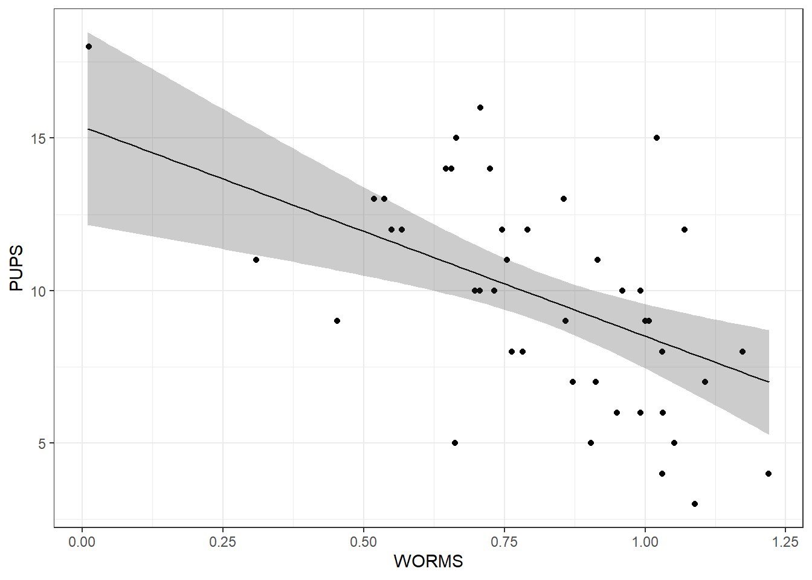
#Result: ####
#The minimal adequate model of wolf recruitment rates showed a significant negative association with parasite load (Slope B =-6.77; Standardized regression coefficient Beta =-1.63; t =-3.68,P= 0.0007; see Figure 1A) and a positive association with the number of moose calves (B = 0.044, Beta = 1.26; t = 2.83; P = 0.0071; see Figure 1B). Because moose calf numbers were colinear with adult population size, we cannot distinguish between the effects of adults or calves on wolf recruitment
#Limitation: Wolf pup numbers may be affected by other predictors not studied as well.

